Opportunities for Future Research:

While our analysis did bear fruit, it left something to be desired. We had quite a bit of interesting data that, due to time constraints, we ended up not being able to use. For example, we looked at the breakdown by crime type in the exploratory stage, but we were not able to utilize this information in our analysis. This would be an obvious first step in developing a better model of criminal activity in England.

Another area where our project could have been improved was in creating the visualizations. This was the main focus of our project but, unfortunately, we spent too much time trying to make GMapPlot work well (it needs a lot of work before it should be used professionally), and by the time we switched back to normal figure plots in Bokeh, we didn’t have time left to figure out how to add desirable features like multiple overlays (one for crime, one for unemployment), date selection options, or crime type selection options. Based on what we came across while researching visualization tools, OpenStreetMaps might have been a better tool to use for what we wanted to accomplish.

In the exploratory analysis phase, we discovered that our dataset contains a distinct cluster of high-crime districts (Figure 1). We did not have time to look into this phenomenon in any great detail. Looking at the clusters individually might have pointed us in the direction of the root causes of high crime levels. 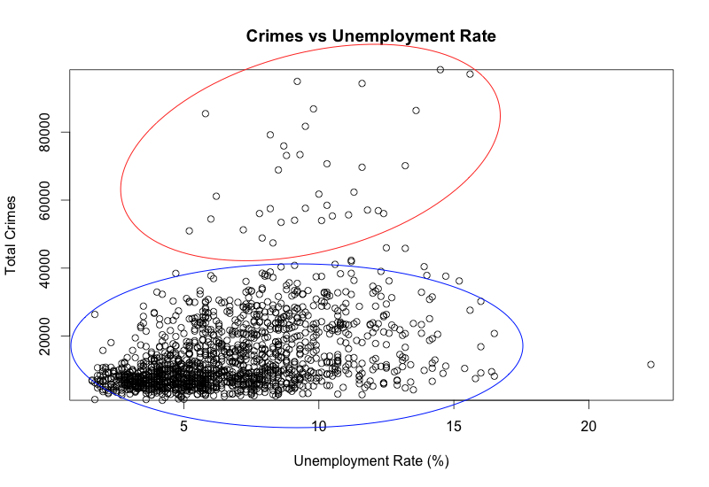

Figure – In this plot of Total Crime vs. Unemployment Rate, there are distinct clusters of high-crime and low-crime LADs.

Finally, our analysis was limited to the UK. The US is in the midst of a push to open police data to the public, and as a result datasets similar in scope and detail to what we worked with are now available for other areas. Other countries also have public repositories of police data. Conducting the same type of research on countries besides the UK would provide insight into the differences in crime across countries, and might reveal which economic and social factors are associated with higher crime rates.